Good day Himanshu,

thank you again for the updates. Please note a number of requested updates are not completed. we really suggest that you give us access to the design of the website so we can make the changes. This is really causing alot of back and forth.

Previously we requested that the logo start by the line before be thrifty and end by the line after FAQ. We also requested that "free shipping when you spend over $1000 should be centered with with the logo. There is no symmetry in your header. The last header you sent, starts in the middle the line at the end, not at the beginning as requested, of be thrifty, and ends in the middle, not in the end as requested, of FAQs

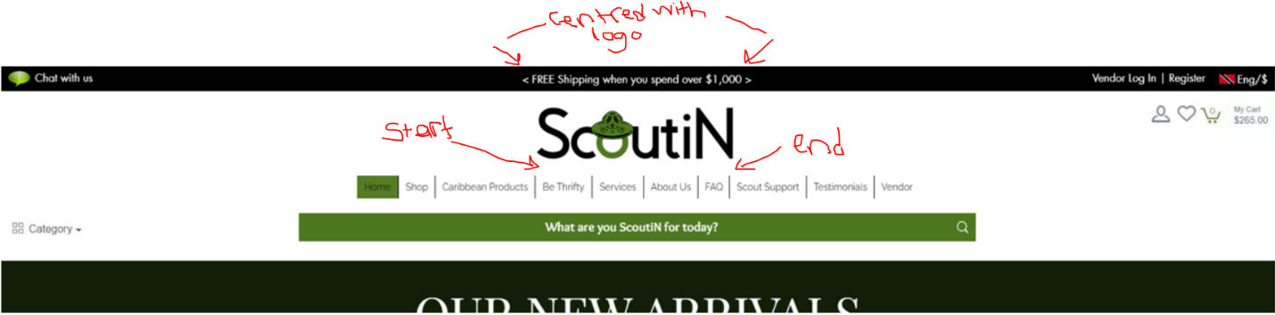

please ensure that the wishlist, profile/sign in, and cart icons are the same size and equally apart to allow easily hovering over to be easy to read. Also make these icons all black in colour.

You advised that the images in shop page has the same format as sales section and this is not the case. Once again, all products should have the below details in the display view:

1. name of store

2. rating

3. product description

4. number of sales

5. product price (highlight should be one of ScoutiN Theme cololurs)

ONLY the sale section on the home page still has this view. This is not what was requested on our last update. This should be on ALL items displayed.

to be clear:

The below is wrong where the product view only has product description, number of sales and price.

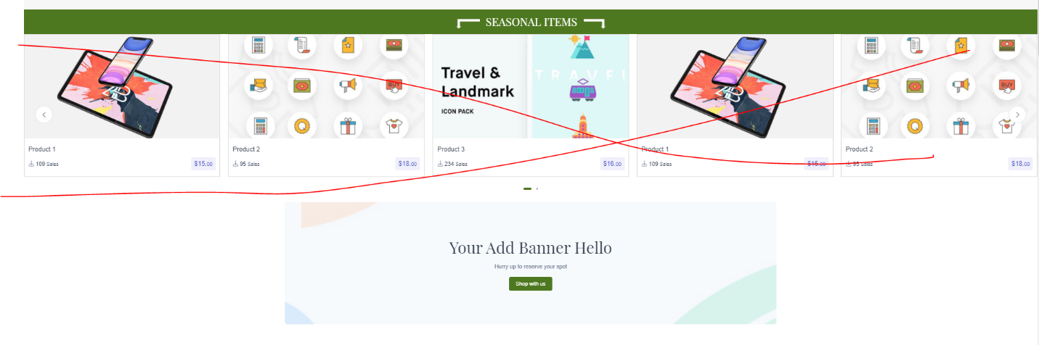

The below snipet from our last update is correct. We beg of you to follow what is on the PDF. Here you see name of store, product description, rating, price and number of sales. The only problem here is that the rating is in yellow when it should be in green.

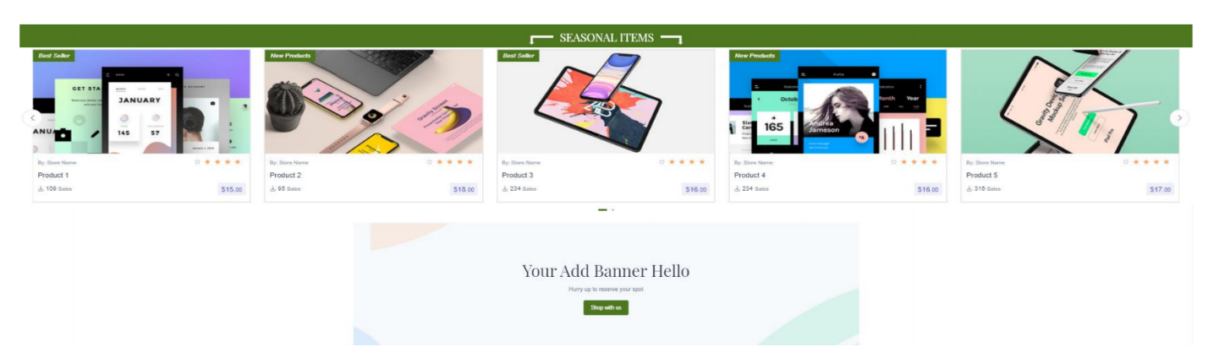

see again how the products should be displayed in Buy again:

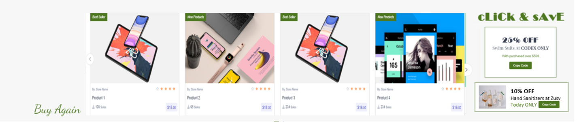

see again how the products should be displayed in the Thrift section, and how large the recycle logo and the title is

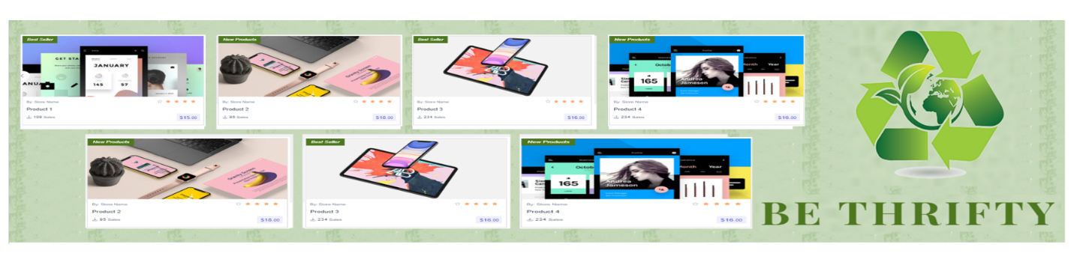

see again another example, of how the product should be displayed on the shop page, the be thrifty page, the caribbean products page, and even how it should be displayed on the services page. You see clearly the store, the rating, the description, the number of sales, the price. In the vendor ministores, this should be the same. This should be the way, any time a product or service is displayed on a page, it should have these items on it.

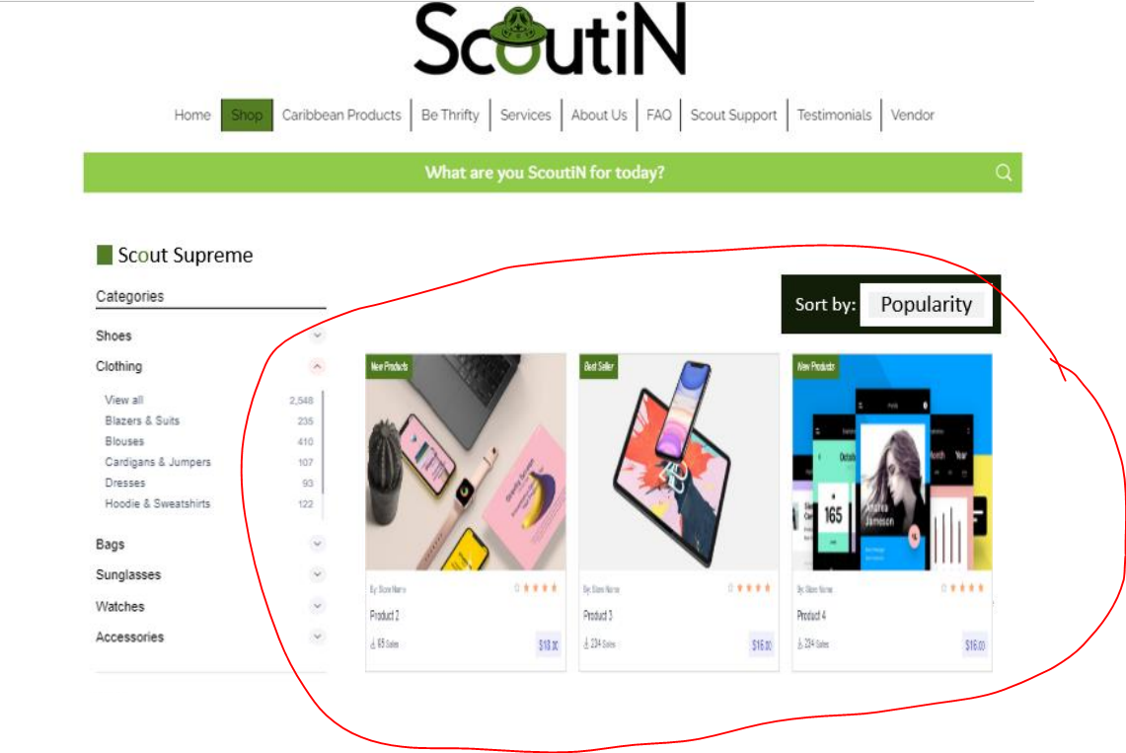

Another issue below, i have gone to the shop page, but home is still highlighted and shop is not highlighted.  We requested this previously, shop should be highlighted in green, home should NOT be highlighted. The page that is selected should have the highlight and ONLY the page that is selected should have the highlight at this point. Vendor text, should not be green. it should be black. it should be black until someone hovers over it, then the text turns green, then if it is selected then the page would turn green and NO OTHER PAGE would be green. ONLY the page selected would be highlighted green, ONLY the page hovered over will have green font. ALL other page fonts will simply stay in black text.

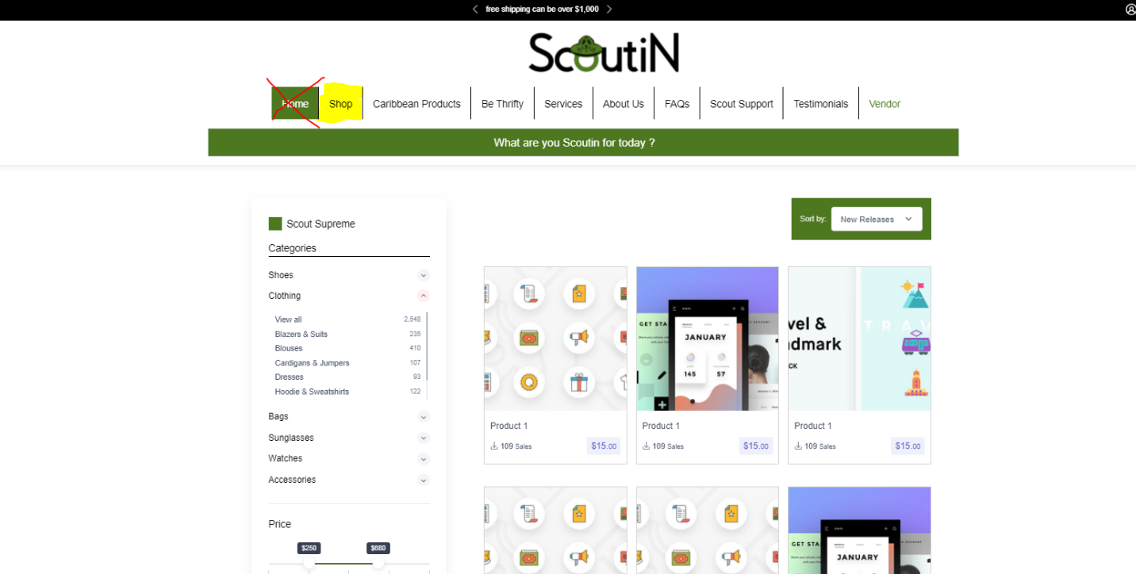

When we hover over a product and the below icons come up, it should say cart, buy now, wishlist. Whether it says that immediately or when it is then hovered over... persons need to know what these icons are. Also reminder, mentioned before, if the person clicks the buy now option, it should bypass every item in the cart and go straight to check out for that item. the items in the cart remain as is.

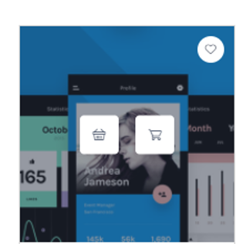

We also still have not seen a wishlist page or a registry page or even a form to fill out a registry or anything.

the single unit page looks pretty good except that the below may change based on the product type. Also where there is "Store name" was requested to be changed to "Sold by:"

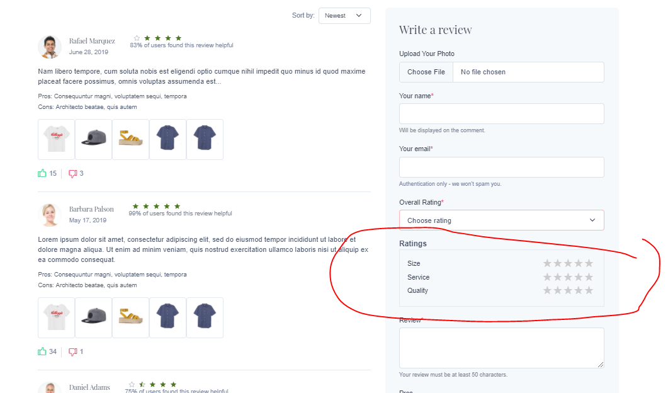

I also asked about customization on the single product view, and havent received any feedback on this. Please let me know if this is possible.

Also persons should be able to click on the photos posted in reviews to see an enlarged photo.

The cart looks really good. However, the items selected to be removed from cart to purchase later need to go at the bottom or to another page or to another view or somewhere that persons can access these items.

Check out page:

again, shipping address should not have something to fill out under address. The part to fill out will be street address 1 and street address 2. By country, we should be choosing countries, not cities. By city there should be a drop down option for the cities/towns. These too were requested before but have not been updated. This also applies to billing address.

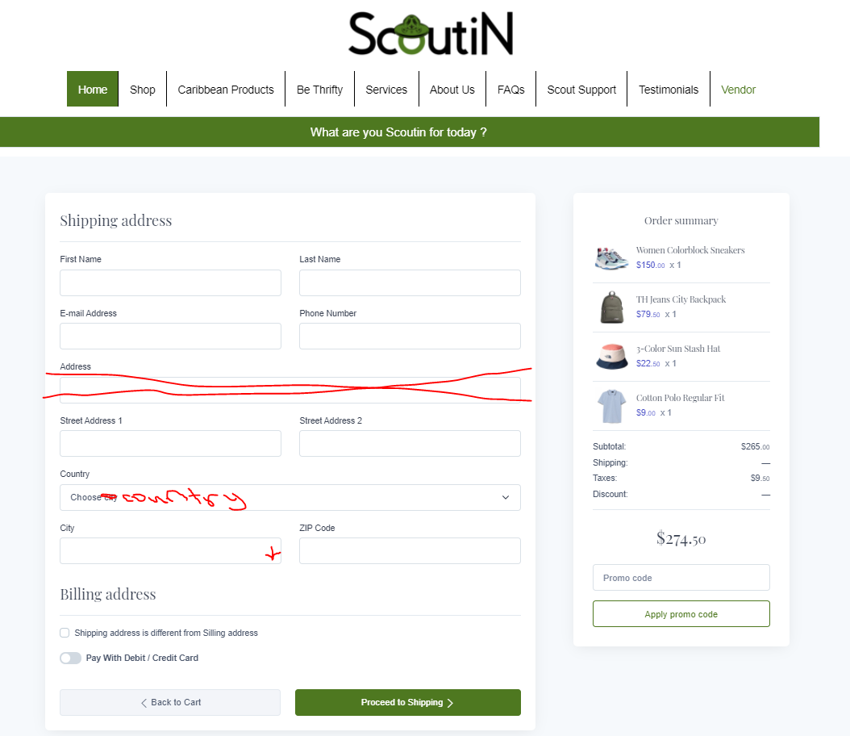

Also requested previously, in the order summary, if an item is a gift, it should say it is a gift.

Testimonials - we requested to have the overall ratings to the left of the page, not as a filter. Please replicate the PDF. If for some reason this cannot be done, please communicate this.

Vendor Ministore:

When we click the category, it should go to the products that are in that category.

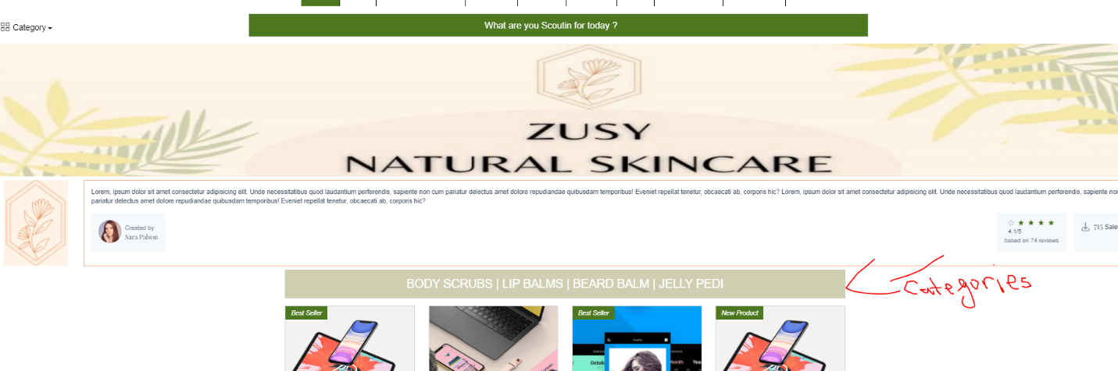

we also asked to have featured items in the vendor store MUCH bigger than the other items. see below:

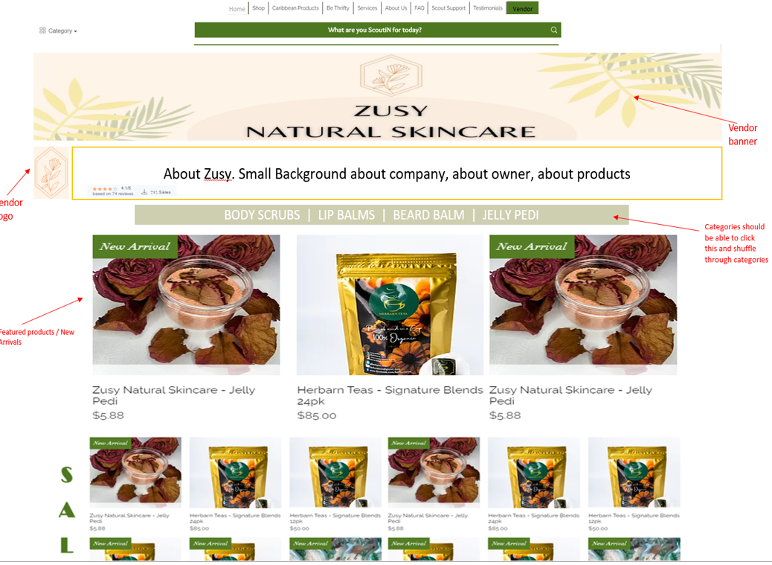

when we hover over the vendor products it still has the random eye that we requested to change to buy now.

Below is not what was requested for the sign up page for shoppers.

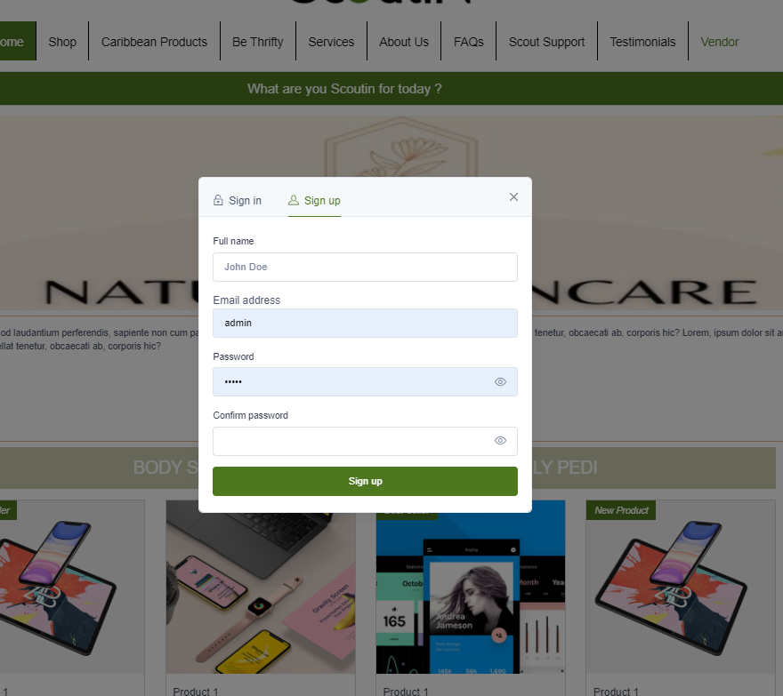

Below is what was sent on the brief

New customer profile:

* Name
* Nickname (name on homepage/profile should be nickname if this option is filled out. Otherwise personalize with regular name)
* email address
* date of birth (y/m/d)
* shipping address
* Phone number (x.xxx.xxx.xxxx)
* Gender (male/female/other/neutral)
* Age 18-24 25-34 35-44 45-54 55-64 >65
* Marital Status single widowed separated divorced married
* Children yes/no
* Country of residence
* Country of origin
* Hobbies (some specific hobbies have been identified to pop up here where the customer can choose. These hobbies will filter into the “things you may like” options etc)
* What type of items do you usually buy (our categories to be listed here and filter into the “things you may like” options etc)

There will also be a terms and agreements for the shopper to click on to read and tick the box as acceptance. This will be part of the sign up process.

Again, for the vendor account, persons should be able to click on the terms and agreements of the website and the vendor contract to reach it, and then tick the box to accept/agree with it. In the below i am unable to click on either of these pages.

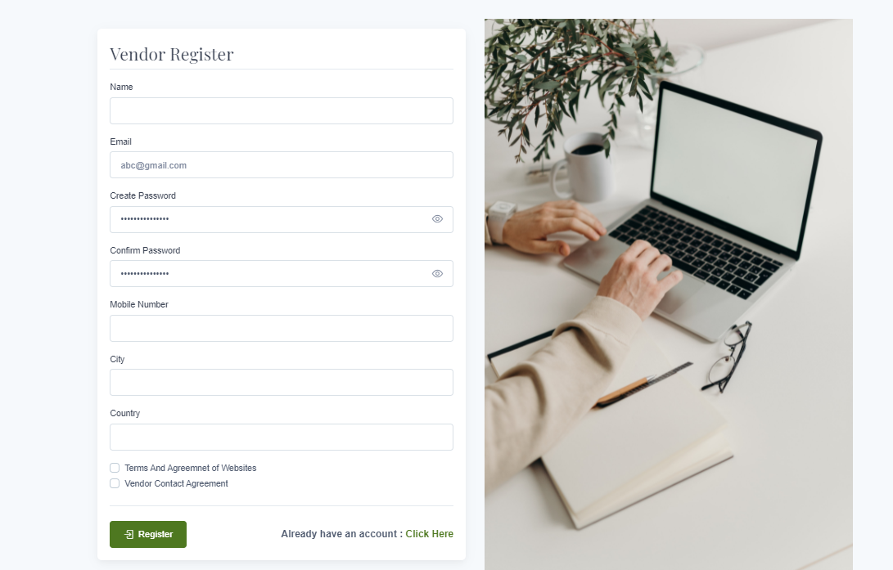

Please take note of other information in our agreement. This is what is most important and critical. We are concerned as we have not started seeing functionalities and have been working on design for a month. The functionalities and coding is MOST important here.

Vendors to have different logins and different types of membership Vendor/Supplier Membership – Simple Scout Membership (regular basic membership, may limit the number of products you can have on the website at any given time), and Supreme Scout Membership (where free ads may be build in, more products can be listed, shipping arrangements will be built in eg free delivery etc). We want to be able to edit this if necessary. Customer/Shopper Membership – Simple Scout Membership (regular basic membership), and Supreme Membership where you get more discounts available to you that simple scouts aren’t able to see, free shipping, shorter shipping times, maybe even more options of products etc). We would like to be able to edit this as we go along. Add and remove membership perks.

This would mean for registration, both vendors and shoppers would need to identify if they would be registering as a Standard/Simple Scout or a Supreme Scout membership. This is also something they would have to click to select on registration pages. Please take note of the functionalities in these.

Vendor Ministore Infomation

Vendors must have different logins and types of membership. They must be able to upload their own products based on the criteria in the contract, and this has to be approved from the website manager/administrator within 24hrs before it is displayed or go live on the website. we would like to have the option to include an automatic mark up % on the vendor price of the products that is not visible to the customer as the customer only sees the final price. We have not confirmed if we would like to use this, however we would like to have the option. I would like when the vendor is uploading their products there is a keywords part where it will pop up in search based on those keywords

Buy again function based on items persons would have purchased before. This will show up on home screen and even on the products 4. Things you may like to pop up to create customized shopping experience based on customers putting interests etc when signing up. see below these functionalities: On the home page we want to have different shopping options: • New arrivals (new stores, new products, new designers, new services etc) - currently have this • Items on sale - currently have this • Clip and save / coupon section where persons can click and redeem coupon or add to their cart - new functionality request • Buy again, where items persons purchased before comes up on their screen - new functionality request • Featured items - currently have this • Things you may like based on the 3 categories you selected in your initial sign up form. Moving forward, we would like to amend this where we can build more information to create a customer profile to personalize the shopping experience. We would like this function built in so that we can edit as we go along. - new functionality request • Ads that persons can click, hover/view and enter to shop - new functionality request • Featured items pulled from the made in Caribbean category/page - currently have this • Awesome finds – steal of deals based on % discount offered or something to that extent. Even new items that may be related to the categories that the shoppers placed in their sign up form - liked to things you may like functionality. • Be thrifty – featured items from our thrifty section - currently have this • Sponsored items based on paid sponsorship from our vendors - believe we currently have this • Seasonal Items - currently have this • Trending items (eg home office things may be trending now as a lot more persons are working from home and homeschooling) - currently have this

Vendors Dashboard:

* Add / Edit Product - Simple and variable
* Orders
* Coupons
* Reviews
* Withdrawal Request
* Return Request
* Add Staff
* Followers
* Support
* Profile

 Vendors Store:

* Follow
* Get Support
* Share
* Products
* Categories
* Contact the Vendor Form

 Membership :

User

* Normal
* Supreme Membership = ' This product can only be viewed by members.'

Vendors

* Normal - Control number of Products
* Supreme Membership -

Payment options needed to be integrated

* o Credit Card (VISA, Mastercard etc)
* o Visa Debit Card
* o Paypal
* o Bank Transfer (receipt has to be able to be uploaded with this option)
* o Cash on Delivery (not sure if we would use this option but we would like to have it available

Furthermore, we would like that when a customer adds an item to the cart, the page should not go directly to the cart. There must always be continuity of shopping. It can pop up at the side or by the cart showing that it is in cart.

We would like if you can share information on how the current ordering process would be based on your quote with this coding for the multivendor site. Below is our ideal situation:

Shopping experience must feel as symplistic and automated as possible for all parties. There must be full transparency from the time a sale is made.

● Shopper MUST be able to track the process of the order stage:

○ Order stage (this is when order is released from webpage manager/administrator and only after released it will be sent to the vendor. Automatic response should read that order has been placed of x amt for x cost, would be ready for pick up in x number of days. A Scout Cust Service Rep will contact to make pick up arrangements)

○ Picking/preparation stage (the vendor then prepares the order for pick up, and updates the system to advise that it is in picking/prep stage)

○ Leaves vendor facility (vendor and delivery person now confirms that order has left the facility and is on the way to the distribution centre)

○ Received at distribution centre and in preparation stage (distribution centre and delivery person confirms that order has been delivered to distribution centre, where distribution centre now ensures that everything is intact for the order to go out well)

○ Out for delivery (distribution centre and delivery man confirms that the order has left the distribution centre and is now out for delivery. Someone from the team now updates the system confirming number of days for delivery eg same day, next day etc)

○ Order delivered (delivery confirmation sent, product has been received. If photo can be uploaded this would be nice, if not, this is ok)

If there are any delays it should be listed and the person causing the delay should update. Anything going on the site should always receive final approval from website administrator before it is shown on the website. Even order status.

Gentle reminder that we still have the services page to work on. We expected this to be completed this week. Be Thrifty page is also outstanding.

Services Page – should be similar format to requested Shop page, instead the filters will be different. Eg. categories will be different services offered eg. Babysitting, grocery shopping, make up artist etc, hairstylist, clothing designer, home furnishings carpenter.; price will remain, instead of colour we will have availability by year, month and date; instead of size we will have location, another filter can be rating, another filter can be years of operation etc. But same look and feel as services page.